# **MONGO DB DAY-2 TASK**

**DATA :**

[

{

"_id": {

"$oid": "65b36b000884ad9249b0b31e"

},

"User": "student",

"Name": "sud 1",

"codeKata": 20,

"mentors": [

{

"Name": "guru",

"No_of_student": 32

},

{

"Name": "vibitha",

"No_of_student": 20

},

{

"Name": "vinoth",

"No_of_student": 26

},

{

"Name": "Sumi",

"No_of_student": 26

},

{

"Name": "jin",

"No_of_student": 15

},

{

"Name": "sugan",

"No_of_student": 36

},

{

"Name": "moni",

"No_of_student": 16

},

{

"Name": "venba",

"No_of_student": 15

}

],

"Title": [

{

"Date": "26-Sept-2020",

"topic": "Introduction to Browser & web"

},

{

"Date": "30-Sept-2020",

"topic": "OOPs in JS"

},

{

"Date": "12-Oct-2020",

"topic": " HTML recap CSS"

},

{

"Date": "17-Oct-2020",

"topic": " Boot strap"

},

{

"Date": "22-Oct-2020",

"topic": "Array Methods"

},

{

"Date": "27-Oct-2020",

"topic": "HTML "

},

{

"Date": "30-Oct-2020",

"topic": "React components"

},

{

"Date": "03-Nov-2020",

"topic": "react router"

},

{

"Date": "08-Nov-2020",

"topic": "UserRef, UseReducer"

},

{

"Date": "15-Nov-2020",

"topic": "Database - MySQL"

}

],

"Task": [

{

"Date": "26-Sept-2020",

"Is_submitted": "yes"

},

{

"Date": "30-Sept-2020",

"Is_submitted": "yes"

},

{

"Date": "12-Oct-2020",

"Is_submitted": "yes"

},

{

"Date": "17-Oct-2020",

"Is_submitted": "yes"

},

{

"Date": "22-Oct-2020",

"Is_submitted": "yes"

},

{

"Date": "27-Oct-2020",

"Is_submitted": "yes"

},

{

"Date": "30-Oct-2020",

"Is_submitted": "yes"

},

{

"Date": "03-Nov-2020",

"Is_submitted": "yes"

},

{

"Date": "08-Nov-2020",

"Is_submitted": "yes"

},

{

"Date": "15-Nov-2020",

"Is_submitted": "yes"

}

],

"Attendance": [

{

"Date": "26-Sept-2020",

"state": "p"

},

{

"Date": "30-Sept-2020",

"state": "p"

},

{

"Date": "15-Oct-2020",

"state": "p"

},

{

"Date": "17-Oct-2020",

"state": "p"

},

{

"Date": "22-Oct-2020",

"state": "p"

},

{

"Date": "27-Oct-2020",

"state": "p"

},

{

"Date": "30-Oct-2020",

"state": "p"

},

{

"Date": "03-Nov-2020",

"state": "p"

},

{

"Date": "08-Nov-2020",

"state": "p"

},

{

"Date": "15-Nov-2020",

"state": "p"

}

],

"company_drive": [

{

"Name": "Micro land",

"Date": "26-Sept-2020",

"Appeaed": "yes"

},

{

"Name": "Cignity",

"Date": "30-Oct-2020",

"Appeaed": "yes"

},

{

"Name": "Coforge",

"Date": "25-Oct-2020",

"Appeaed": "yes"

},

{

"Name": "Accel",

"Date": "06-Nov-2020",

"Appeaed": "No"

},

{

"Name": "Oracle",

"Date": "21-Oct-2020",

"Appeaed": "No"

},

{

"Name": "HCL",

"Date": "16-Oct-2020",

"Appeaed": "yes"

}

]

},

{

"_id": {

"$oid": "65b37f920884ad9249b0b31f"

},

"User": "student",

"Name": "sud 2",

"codeKata": 25,

"mentors": [

{

"Name": "guru",

"No_of_student": 32

},

{

"Name": "vibitha",

"No_of_student": 20

},

{

"Name": "vinoth",

"No_of_student": 26

},

{

"Name": "Sumi",

"No_of_student": 26

},

{

"Name": "jin",

"No_of_student": 15

},

{

"Name": "sugan",

"No_of_student": 36

},

{

"Name": "moni",

"No_of_student": 16

},

{

"Name": "venba",

"No_of_student": 15

}

],

"Title": [

{

"Date": "26-Sept-2020",

"topic": "Introduction to Browser & web"

},

{

"Date": "30-Sept-2020",

"topic": "OOPs in JS"

},

{

"Date": "12-Oct-2020",

"topic": " HTML recap CSS"

},

{

"Date": "17-Oct-2020",

"topic": " Boot strap"

},

{

"Date": "22-Oct-2020",

"topic": "Array Methods"

},

{

"Date": "27-Oct-2020",

"topic": "HTML "

},

{

"Date": "30-Oct-2020",

"topic": "React components"

},

{

"Date": "03-Nov-2020",

"topic": "react router"

},

{

"Date": "08-Nov-2020",

"topic": "UserRef, UseReducer"

},

{

"Date": "15-Nov-2020",

"topic": "Database - MySQL"

}

],

"Task": [

{

"Date": "26-Sept-2020",

"Is_submitted": "No"

},

{

"Date": "30-Sept-2020",

"Is_submitted": "yes"

},

{

"Date": "12-Oct-2020",

"Is_submitted": "yes"

},

{

"Date": "17-Oct-2020",

"Is_submitted": "yes"

},

{

"Date": "22-Oct-2020",

"Is_submitted": "No"

},

{

"Date": "27-Oct-2020",

"Is_submitted": "yes"

},

{

"Date": "30-Oct-2020",

"Is_submitted": "yes"

},

{

"Date": "03-Nov-2020",

"Is_submitted": "No"

},

{

"Date": "08-Nov-2020",

"Is_submitted": "yes"

},

{

"Date": "15-Nov-2020",

"Is_submitted": "No"

}

],

"Attendance": [

{

"Date": "26-Sept-2020",

"state": "p"

},

{

"Date": "30-Sept-2020",

"state": "A"

},

{

"Date": "15-Oct-2020",

"state": "p"

},

{

"Date": "17-Oct-2020",

"state": "A"

},

{

"Date": "22-Oct-2020",

"state": "p"

},

{

"Date": "27-Oct-2020",

"state": "p"

},

{

"Date": "30-Oct-2020",

"state": "A"

},

{

"Date": "03-Nov-2020",

"state": "p"

},

{

"Date": "08-Nov-2020",

"state": "p"

},

{

"Date": "15-Nov-2020",

"state": "p"

}

],

"company_drive": [

{

"Name": "Micro land",

"Date": "26-Sept-2020",

"Appeaed": "No"

},

{

"Name": "Cignity",

"Date": "30-Oct-2020",

"Appeaed": "yes"

},

{

"Name": "Coforge",

"Date": "25-Oct-2020",

"Appeaed": "yes"

},

{

"Name": "Accel",

"Date": "06-Nov-2020",

"Appeaed": "No"

},

{

"Name": "Oracle",

"Date": "21-Oct-2020",

"Appeaed": "No"

},

{

"Name": "HCL",

"Date": "16-Oct-2020",

"Appeaed": "yes"

}

]

},

{

"_id": {

"$oid": "65b381690884ad9249b0b320"

},

"User": "student",

"Name": "sud 4",

"codeKata": 25,

"mentors": [

{

"Name": "guru",

"No_of_student": 32

},

{

"Name": "vibitha",

"No_of_student": 20

},

{

"Name": "vinoth",

"No_of_student": 26

},

{

"Name": "Sumi",

"No_of_student": 26

},

{

"Name": "jin",

"No_of_student": 15

},

{

"Name": "sugan",

"No_of_student": 36

},

{

"Name": "moni",

"No_of_student": 16

},

{

"Name": "venba",

"No_of_student": 15

}

],

"Title": [

{

"Date": "26-Sept-2020",

"topic": "Introduction to Browser & web"

},

{

"Date": "30-Sept-2020",

"topic": "OOPs in JS"

},

{

"Date": "12-Oct-2020",

"topic": " HTML recap CSS"

},

{

"Date": "17-Oct-2020",

"topic": " Boot strap"

},

{

"Date": "22-Oct-2020",

"topic": "Array Methods"

},

{

"Date": "27-Oct-2020",

"topic": "HTML "

},

{

"Date": "30-Oct-2020",

"topic": "React components"

},

{

"Date": "03-Nov-2020",

"topic": "react router"

},

{

"Date": "08-Nov-2020",

"topic": "UserRef, UseReducer"

},

{

"Date": "15-Nov-2020",

"topic": "Database - MySQL"

}

],

"Task": [

{

"Date": "26-Sept-2020",

"Is_submitted": "No"

},

{

"Date": "30-Sept-2020",

"Is_submitted": "yes"

},

{

"Date": "12-Oct-2020",

"Is_submitted": "No"

},

{

"Date": "17-Oct-2020",

"Is_submitted": "yes"

},

{

"Date": "22-Oct-2020",

"Is_submitted": "yes"

},

{

"Date": "27-Oct-2020",

"Is_submitted": "yes"

},

{

"Date": "30-Oct-2020",

"Is_submitted": "yes"

},

{

"Date": "03-Nov-2020",

"Is_submitted": "yes"

},

{

"Date": "08-Nov-2020",

"Is_submitted": "No"

},

{

"Date": "15-Nov-2020",

"Is_submitted": "No"

}

],

"Attendance": [

{

"Date": "26-Sept-2020",

"state": "p"

},

{

"Date": "30-Sept-2020",

"state": "A"

},

{

"Date": "15-Oct-2020",

"state": "A"

},

{

"Date": "17-Oct-2020",

"state": "p"

},

{

"Date": "22-Oct-2020",

"state": "p"

},

{

"Date": "27-Oct-2020",

"state": "p"

},

{

"Date": "30-Oct-2020",

"state": "p"

},

{

"Date": "03-Nov-2020",

"state": "A"

},

{

"Date": "08-Nov-2020",

"state": "p"

},

{

"Date": "15-Nov-2020",

"state": "p"

}

],

"company_drive": [

{

"Name": "Micro land",

"Date": "26-Sept-2020",

"Appeaed": "No"

},

{

"Name": "Cignity",

"Date": "30-Oct-2020",

"Appeaed": "yes"

},

{

"Name": "Coforge",

"Date": "25-Oct-2020",

"Appeaed": "No"

},

{

"Name": "Accel",

"Date": "06-Nov-2020",

"Appeaed": "No"

},

{

"Name": "Oracle",

"Date": "21-Oct-2020",

"Appeaed": "yes"

},

{

"Name": "HCL",

"Date": "16-Oct-2020",

"Appeaed": "No"

}

]

},

{

"_id": {

"$oid": "65b3826f0884ad9249b0b321"

},

"User": "student",

"Name": "sud 5",

"codeKata": 65,

"mentors": [

{

"Name": "guru",

"No_of_student": 32

},

{

"Name": "vibitha",

"No_of_student": 20

},

{

"Name": "vinoth",

"No_of_student": 26

},

{

"Name": "Sumi",

"No_of_student": 26

},

{

"Name": "jin",

"No_of_student": 15

},

{

"Name": "sugan",

"No_of_student": 36

},

{

"Name": "moni",

"No_of_student": 16

},

{

"Name": "venba",

"No_of_student": 15

}

],

"Title": [

{

"Date": "26-Sept-2020",

"topic": "Introduction to Browser & web"

},

{

"Date": "30-Sept-2020",

"topic": "OOPs in JS"

},

{

"Date": "12-Oct-2020",

"topic": " HTML recap CSS"

},

{

"Date": "17-Oct-2020",

"topic": " Boot strap"

},

{

"Date": "22-Oct-2020",

"topic": "Array Methods"

},

{

"Date": "27-Oct-2020",

"topic": "HTML "

},

{

"Date": "30-Oct-2020",

"topic": "React components"

},

{

"Date": "03-Nov-2020",

"topic": "react router"

},

{

"Date": "08-Nov-2020",

"topic": "UserRef, UseReducer"

},

{

"Date": "15-Nov-2020",

"topic": "Database - MySQL"

}

],

"Task": [

{

"Date": "26-Sept-2020",

"Is_submitted": "No"

},

{

"Date": "30-Sept-2020",

"Is_submitted": "yes"

},

{

"Date": "12-Oct-2020",

"Is_submitted": "yes"

},

{

"Date": "17-Oct-2020",

"Is_submitted": "No"

},

{

"Date": "22-Oct-2020",

"Is_submitted": "yes"

},

{

"Date": "27-Oct-2020",

"Is_submitted": "yes"

},

{

"Date": "30-Oct-2020",

"Is_submitted": "No"

},

{

"Date": "03-Nov-2020",

"Is_submitted": "yes"

},

{

"Date": "08-Nov-2020",

"Is_submitted": "No"

},

{

"Date": "15-Nov-2020",

"Is_submitted": "No"

}

],

"Attendance": [

{

"Date": "26-Sept-2020",

"state": "p"

},

{

"Date": "30-Sept-2020",

"state": "A"

},

{

"Date": "15-Oct-2020",

"state": "p"

},

{

"Date": "17-Oct-2020",

"state": "p"

},

{

"Date": "22-Oct-2020",

"state": "A"

},

{

"Date": "27-Oct-2020",

"state": "p"

},

{

"Date": "30-Oct-2020",

"state": "A"

},

{

"Date": "03-Nov-2020",

"state": "p"

},

{

"Date": "08-Nov-2020",

"state": "p"

},

{

"Date": "15-Nov-2020",

"state": "A"

}

],

"company_drive": [

{

"Name": "Micro land",

"Date": "26-Sept-2020",

"Appeaed": "No"

},

{

"Name": "Cignity",

"Date": "30-Oct-2020",

"Appeaed": "No"

},

{

"Name": "Coforge",

"Date": "25-Oct-2020",

"Appeaed": "yes"

},

{

"Name": "Accel",

"Date": "06-Nov-2020",

"Appeaed": "No"

},

{

"Name": "Oracle",

"Date": "21-Oct-2020",

"Appeaed": "No"

},

{

"Name": "HCL",

"Date": "16-Oct-2020",

"Appeaed": "No"

}

]

},

{

"_id": {

"$oid": "65b384480884ad9249b0b322"

},

"User": "student",

"Name": "sud 6",

"codeKata": 56,

"mentors": [

{

"Name": "guru",

"No_of_student": 32

},

{

"Name": "vibitha",

"No_of_student": 20

},

{

"Name": "vinoth",

"No_of_student": 26

},

{

"Name": "Sumi",

"No_of_student": 26

},

{

"Name": "jin",

"No_of_student": 15

},

{

"Name": "sugan",

"No_of_student": 36

},

{

"Name": "moni",

"No_of_student": 16

},

{

"Name": "venba",

"No_of_student": 15

}

],

"Title": [

{

"Date": "26-Sept-2020",

"topic": "Introduction to Browser & web"

},

{

"Date": "30-Sept-2020",

"topic": "OOPs in JS"

},

{

"Date": "12-Oct-2020",

"topic": " HTML recap CSS"

},

{

"Date": "17-Oct-2020",

"topic": " Boot strap"

},

{

"Date": "22-Oct-2020",

"topic": "Array Methods"

},

{

"Date": "27-Oct-2020",

"topic": "HTML "

},

{

"Date": "30-Oct-2020",

"topic": "React components"

},

{

"Date": "03-Nov-2020",

"topic": "react router"

},

{

"Date": "08-Nov-2020",

"topic": "UserRef, UseReducer"

},

{

"Date": "15-Nov-2020",

"topic": "Database - MySQL"

}

],

"Task": [

{

"Date": "26-Sept-2020",

"Is_submitted": "yes"

},

{

"Date": "30-Sept-2020",

"Is_submitted": "yes"

},

{

"Date": "12-Oct-2020",

"Is_submitted": "yes"

},

{

"Date": "17-Oct-2020",

"Is_submitted": "No"

},

{

"Date": "22-Oct-2020",

"Is_submitted": "No"

},

{

"Date": "27-Oct-2020",

"Is_submitted": "yes"

},

{

"Date": "30-Oct-2020",

"Is_submitted": "yes"

},

{

"Date": "03-Nov-2020",

"Is_submitted": "yes"

},

{

"Date": "08-Nov-2020",

"Is_submitted": "No"

},

{

"Date": "15-Nov-2020",

"Is_submitted": "No"

}

],

"Attendance": [

{

"Date": "26-Sept-2020",

"state": "p"

},

{

"Date": "30-Sept-2020",

"state": "A"

},

{

"Date": "15-Oct-2020",

"state": "p"

},

{

"Date": "17-Oct-2020",

"state": "A"

},

{

"Date": "22-Oct-2020",

"state": "A"

},

{

"Date": "27-Oct-2020",

"state": "p"

},

{

"Date": "30-Oct-2020",

"state": "A"

},

{

"Date": "03-Nov-2020",

"state": "p"

},

{

"Date": "08-Nov-2020",

"state": "p"

},

{

"Date": "15-Nov-2020",

"state": "A"

}

],

"company_drive": [

{

"Name": "Micro land",

"Date": "26-Sept-2020",

"Appeaed": "No"

},

{

"Name": "Cignity",

"Date": "30-Oct-2020",

"Appeaed": "No"

},

{

"Name": "Coforge",

"Date": "25-Oct-2020",

"Appeaed": "yes"

},

{

"Name": "Accel",

"Date": "06-Nov-2020",

"Appeaed": "yes"

},

{

"Name": "Oracle",

"Date": "21-Oct-2020",

"Appeaed": "No"

},

{

"Name": "HCL",

"Date": "16-Oct-2020",

"Appeaed": "yes"

}

]

},{

"_id": {

"$oid": "65b387610884ad9249b0b323"

},

"User": "student",

"Name": "sud 7",

"codeKata": 56,

"mentors": [

{

"Name": "guru",

"No_of_student": 32

},

{

"Name": "vibitha",

"No_of_student": 20

},

{

"Name": "vinoth",

"No_of_student": 26

},

{

"Name": "Sumi",

"No_of_student": 26

},

{

"Name": "jin",

"No_of_student": 15

},

{

"Name": "sugan",

"No_of_student": 36

},

{

"Name": "moni",

"No_of_student": 16

},

{

"Name": "venba",

"No_of_student": 15

}

],

"Title": [

{

"Date": "26-Sept-2020",

"topic": "Introduction to Browser & web"

},

{

"Date": "30-Sept-2020",

"topic": "OOPs in JS"

},

{

"Date": "12-Oct-2020",

"topic": " HTML recap CSS"

},

{

"Date": "17-Oct-2020",

"topic": " Boot strap"

},

{

"Date": "22-Oct-2020",

"topic": "Array Methods"

},

{

"Date": "27-Oct-2020",

"topic": "HTML "

},

{

"Date": "30-Oct-2020",

"topic": "React components"

},

{

"Date": "03-Nov-2020",

"topic": "react router"

},

{

"Date": "08-Nov-2020",

"topic": "UserRef, UseReducer"

},

{

"Date": "15-Nov-2020",

"topic": "Database - MySQL"

}

],

"Task": [

{

"Date": "26-Sept-2020",

"Is_submitted": "yes"

},

{

"Date": "30-Sept-2020",

"Is_submitted": "yes"

},

{

"Date": "12-Oct-2020",

"Is_submitted": "yes"

},

{

"Date": "17-Oct-2020",

"Is_submitted": "No"

},

{

"Date": "22-Oct-2020",

"Is_submitted": "No"

},

{

"Date": "27-Oct-2020",

"Is_submitted": "yes"

},

{

"Date": "30-Oct-2020",

"Is_submitted": "yes"

},

{

"Date": "03-Nov-2020",

"Is_submitted": "yes"

},

{

"Date": "08-Nov-2020",

"Is_submitted": "No"

},

{

"Date": "15-Nov-2020",

"Is_submitted": "No"

}

],

"Attendance": [

{

"Date": "26-Sept-2020",

"state": "p"

},

{

"Date": "30-Sept-2020",

"state": "A"

},

{

"Date": "15-Oct-2020",

"state": "p"

},

{

"Date": "17-Oct-2020",

"state": "A"

},

{

"Date": "22-Oct-2020",

"state": "A"

},

{

"Date": "27-Oct-2020",

"state": "p"

},

{

"Date": "30-Oct-2020",

"state": "p"

},

{

"Date": "03-Nov-2020",

"state": "p"

},

{

"Date": "08-Nov-2020",

"state": "p"

},

{

"Date": "15-Nov-2020",

"state": "A"

}

],

"company_drive": [

{

"Name": "Micro land",

"Date": "26-Sept-2020",

"Appeaed": "No"

},

{

"Name": "Cignity",

"Date": "30-Oct-2020",

"Appeaed": "No"

},

{

"Name": "Coforge",

"Date": "25-Oct-2020",

"Appeaed": "yes"

},

{

"Name": "Accel",

"Date": "06-Nov-2020",

"Appeaed": "No"

},

{

"Name": "Oracle",

"Date": "21-Oct-2020",

"Appeaed": "No"

},

{

"Name": "HCL",

"Date": "16-Oct-2020",

"Appeaed": "yes"

}

]

}

]

1. **Find all the topics and tasks**

**db.class.find( {User: "student"},{Title:1, Task:1}).pretty();**

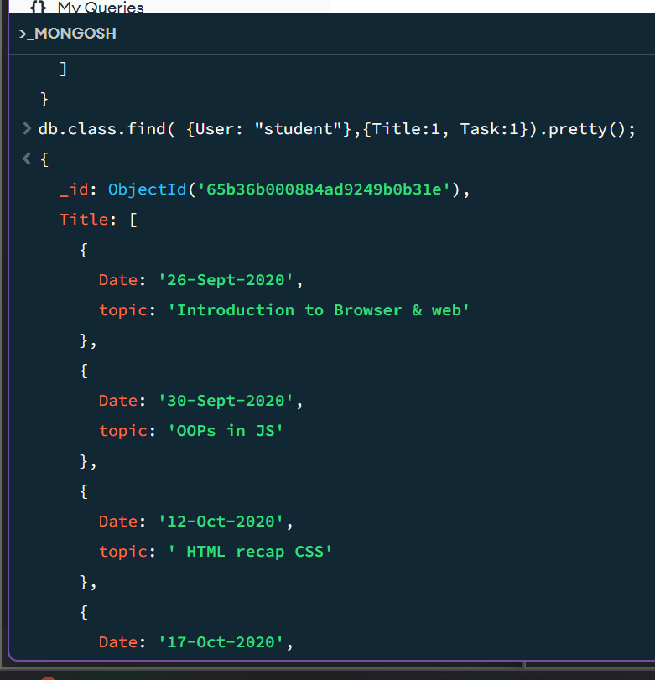

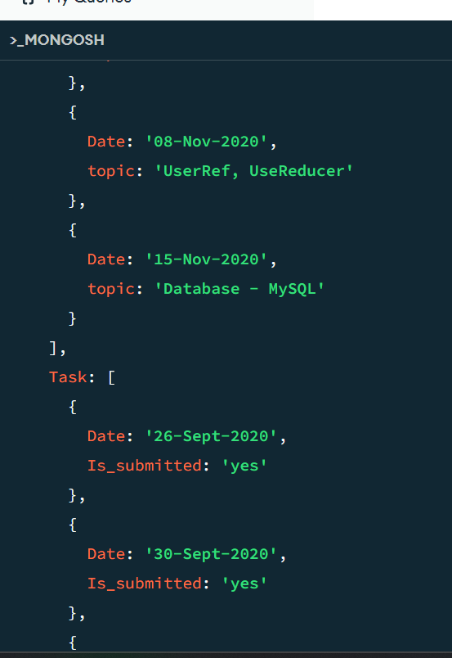

1. **Find all the company drives which appeared between 15 oct-2020 and 31-oct-2020**

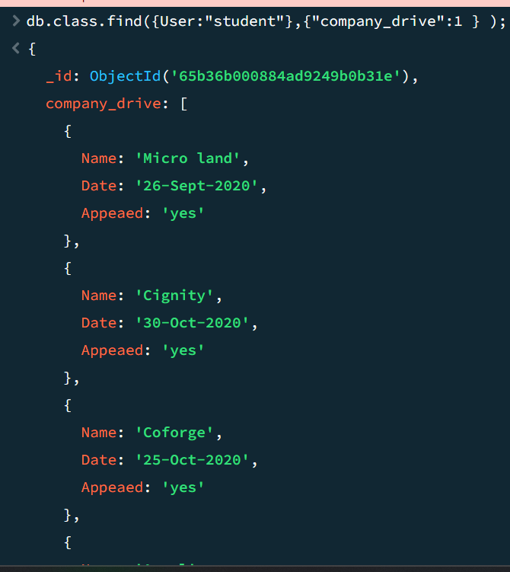

1. **Find all the company drives and students who are appeared for the placement.**

**db.class.find({"company_drive.Appeaed":"yes"});**

1. **Find the number of problems solved by the user in code kata**

**db.class.find({User:"student"},{codeKata:1});**

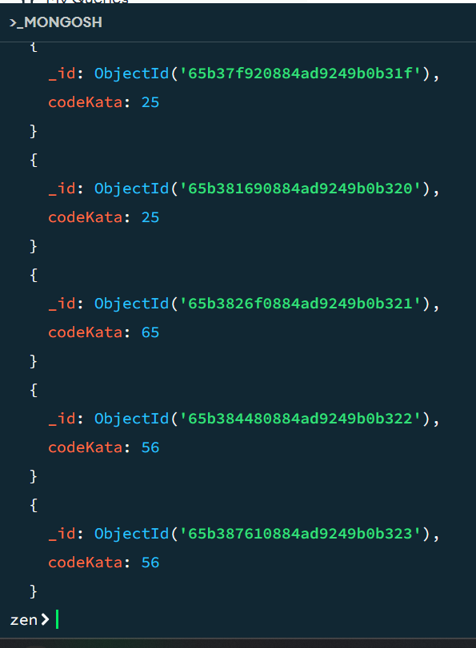

1. **Find all the mentors with who has the mentee's count more than 15**

**db.class.find({"mentors.No_of_student":{$gt:15}});**

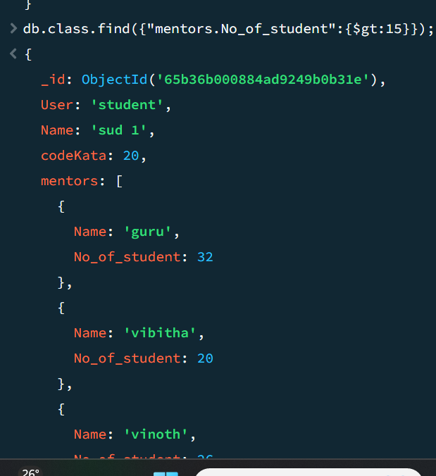

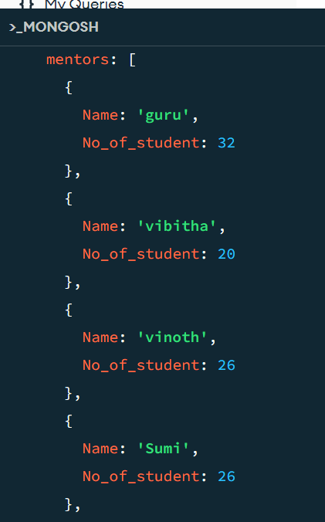

1. **Find the number of users who are absent and task is not submitted between 15 oct-2020 and 31-oct-2020**

**db.class.find({User:"student"},{"Task.Is_submitted":'No',"Attendance.state":'A'});**

